Dinosaurs by Charlie Walters

Tony T-Rex was my first dinosaur toy. I got him when I was two on my birthday. Since then I have loved dinosaurs.

Tyrannosaurus Rex
A T-Rex lived in its happy home 70 million years ago in the Cretaceous period in the past.
A T-Rex is a carnivore.
He weighed around 8 tonnes and was 12 metres long.
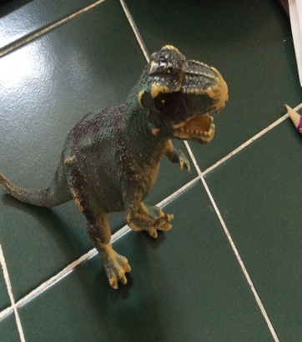
His name means Tyrant lizard.
Tony

Ankylosaurus
On average the Ankylosaurus weighed 5 tonnes and was 10 metres long.
It’s name means stiff lizard.
It was a herbivore.
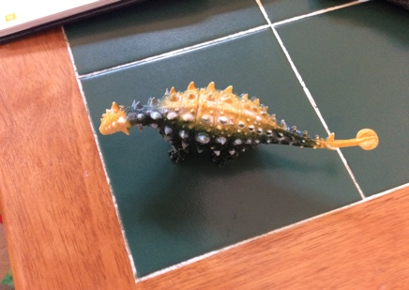
It lived in its happy home 70 million years ago in the Cretaceous period in the past

Velociraptor
It was a carnivore
It weighed on average 25 kilograms and was 1.8 metres long.
It’s name means quick plunderer, h
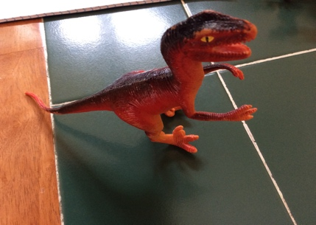
It lived in its happy home 70 million years ago in the Cretaceous period in the past.

Triceratops
It’s job was to defend weaker herbivores than it.
It’s name means 3 horned face.
It weighed 5 tonnes on average.
It was 9 metres long on average.
It lived in its happy home 70 million years ago in the Cretaceous period.
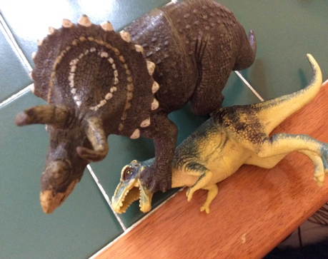
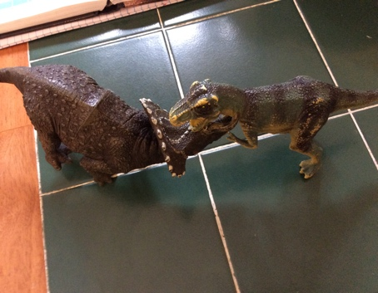

Parasaurolophus
It can warn the Hurd when under attack with noise vibrating from its head.
It weighed 3.5 tonnes.
It was 10 metres long.
It was a herbivore.
It lived in its happy home 70 million years ago in the Cretaceous period.
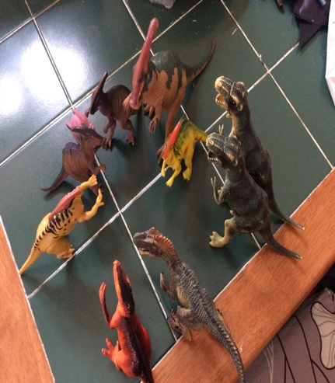

Stegosaurus
Its name means Roofed lizard.
When stegosaurus was mad the plates on his back turned red.
It weighed 2 tonnes.
It was 9 metres long.
It was a herbivore.
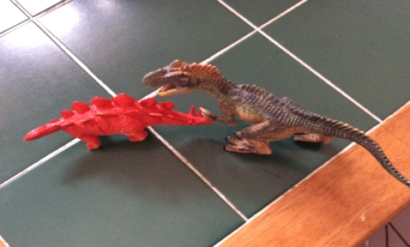
It lived in its happy home 140 million years ago in the Cretaceous period.

