Funny pet stories

The first funny pet story is when i got back from school and i got changed , my school dress was on my bed and i thought it would be funny if i could put my dog in it…. “ROBBIE!!!” He ran up the stairs not knowing what was waiting for him. “Mum Dad! Look what I did!” “what did she do...o you put the dog in your school dress!Haha!” And this is what he looked like!
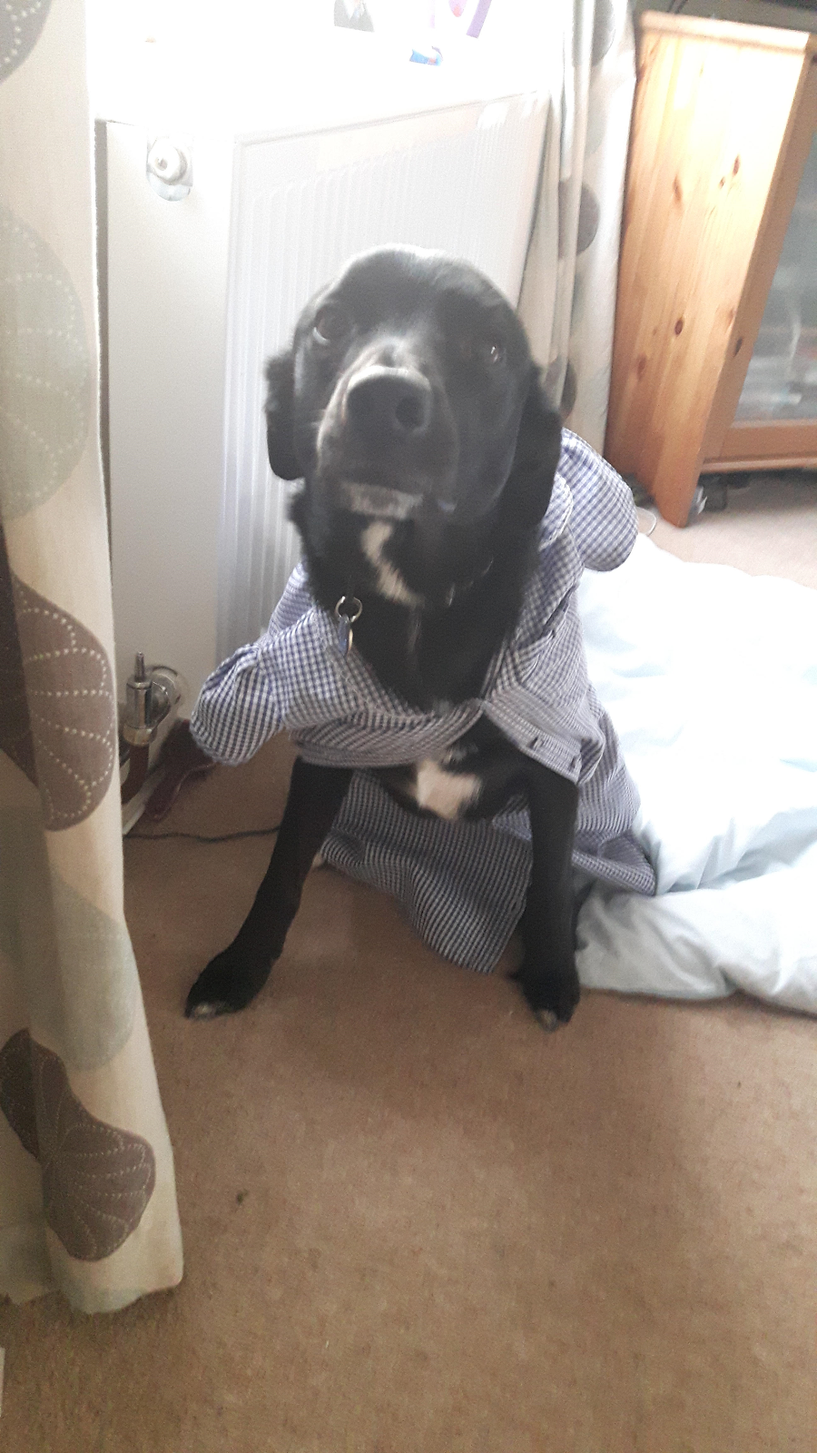
The next story i'm telling you was about our oldest cat Jack Jack like the baby from the incredibles, anyway we were watching tv (probably Harry Potter) and Jack was washing himself and something distracted him and he was sticking his tongue out Xavy(My brother) said he was doing it to the tv ha!

Well here is another Robbie story for you. This story was actually was the second or third week of isolation and we were walking over the vineyards robbie had gone to the swill gate for a swim like usual, and Xavy throwing the stick in and one time Xavy through it to the other side and Robbie jumped into the muddy bank on the other side like a four pronged dart i think he wasn't expecting that he would get his legs drenched in mud.

Another Robbie in the swilgate story. Well the 5th or 6th time in the vineyards Robbie was playing ball and he dropped his ball down the bank he went down to get it and slid, and face planted the mud, half of his face was covered in mud.
Silly dog!

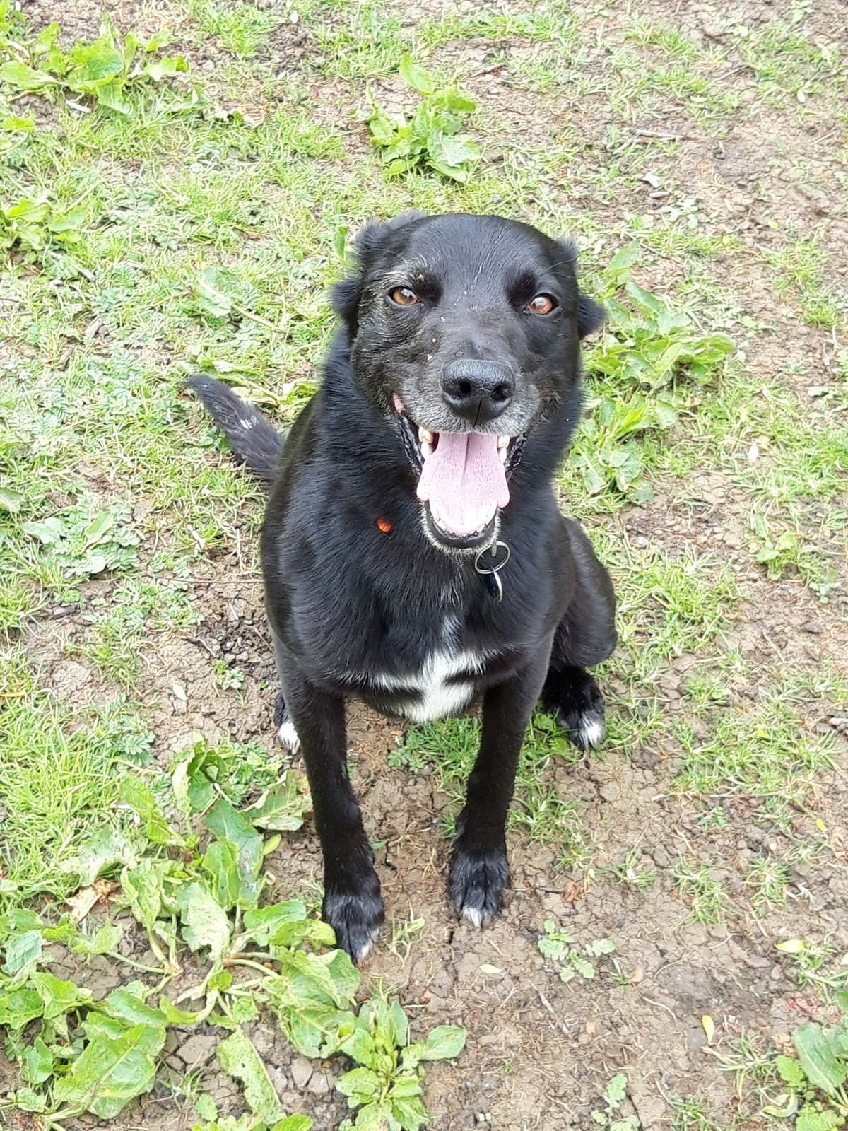

Meet the gang

Tia
Tia is a sass queen. She acts like she owns everything she steals your space at the table if you get a drink or go to the toilet. You maybe think tia is fat but really she is a skinny fluff ball. The little diva loves lounging around in the sun in the living room when she can. Tia is 6 years old like our other 2 cats.
Here is our sassy little devil.
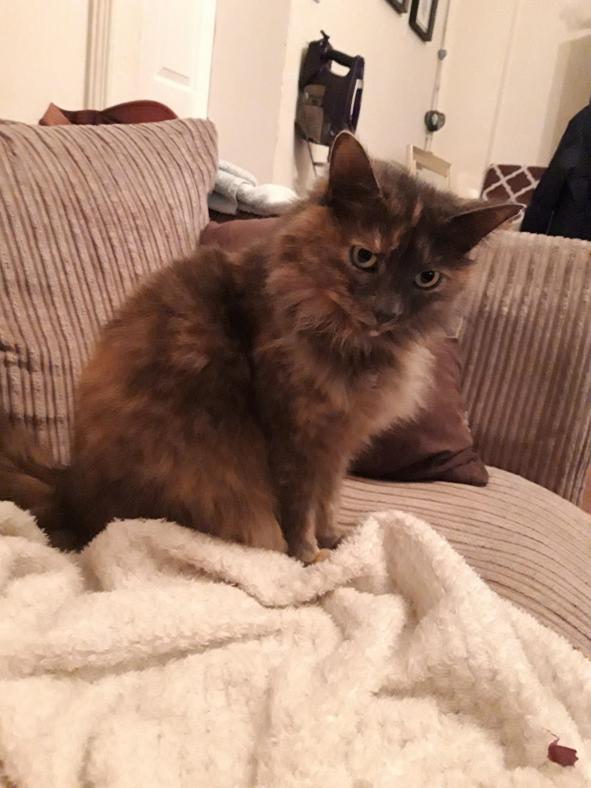

Jack
Jack Jack is our lazy old man .All he does is sit on the sofa ,eat , go to the toilet and sleep anywhere he can get to in the house. Sometimes he tries to get in mum and dad's room to sleep on the bed , funny cat! He is 13 years old and that's pretty old in cat years! He also is a bit of a fatty he steals the other cats food.And here's our old man
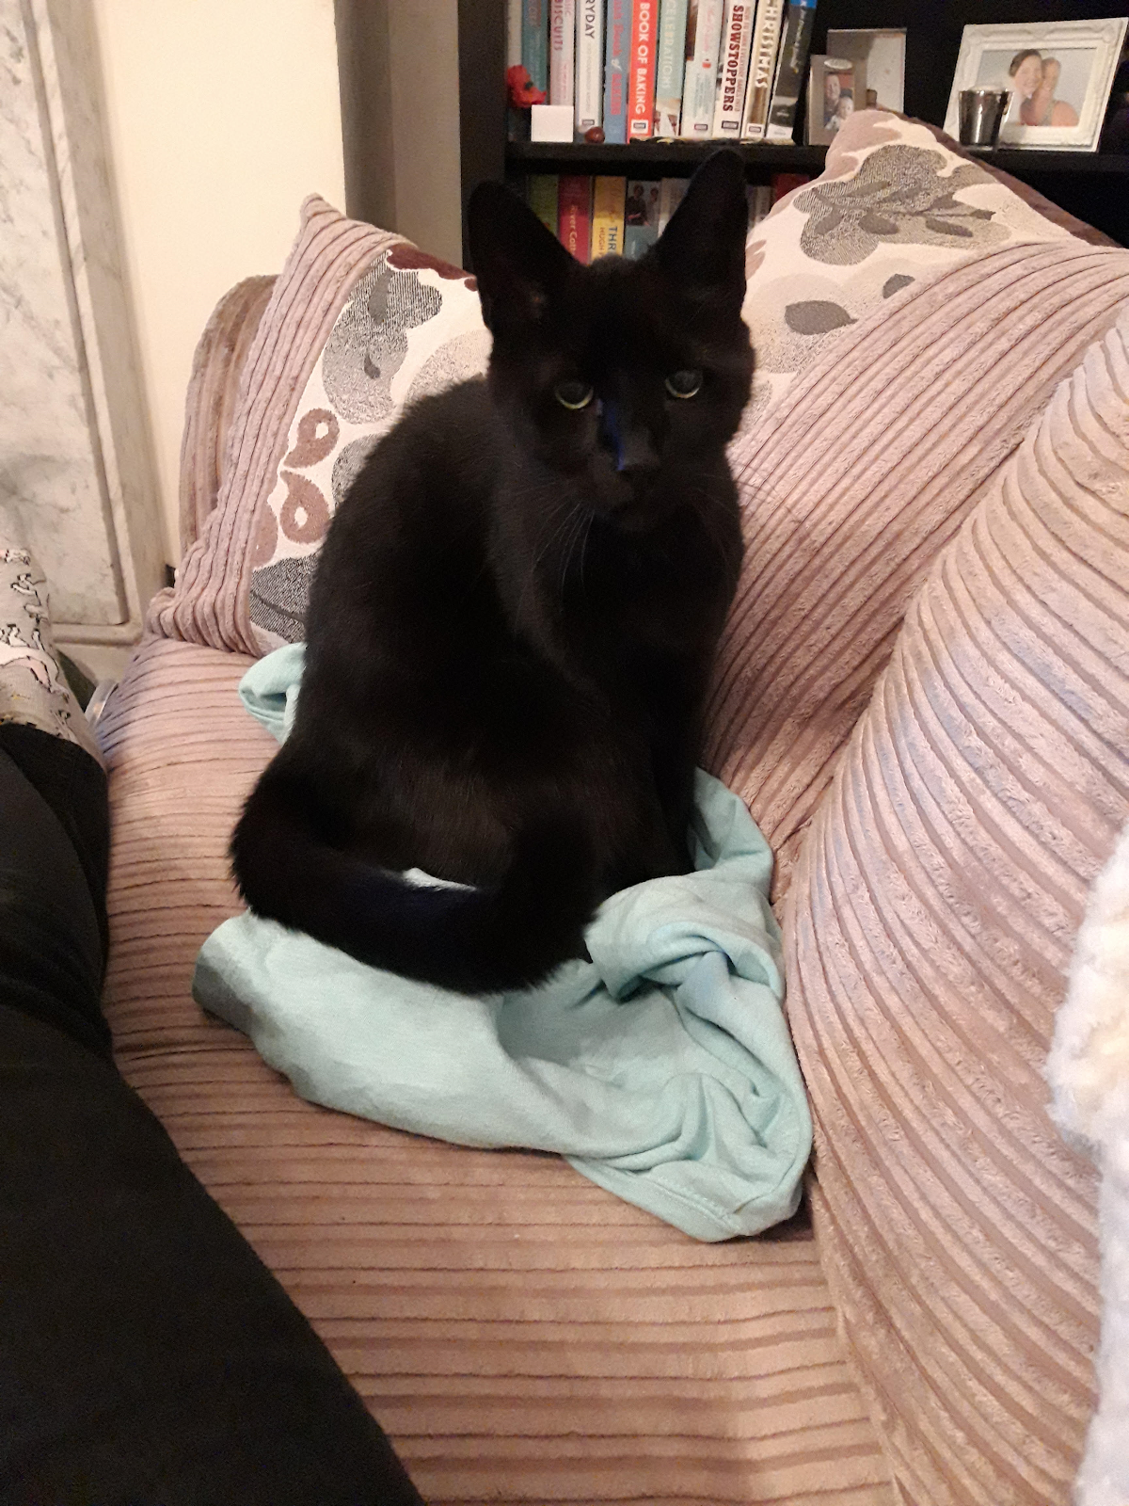

Jassy ( Jasmine)
Jasmine is the boss. Jassy is the enemy of Tia. They hate each other and she even hates Robbie, our doggy .She loves attacking long bits of grass when we move it around. She is 6 years old like Jasper and Tia the other cats.
Here's the boss.
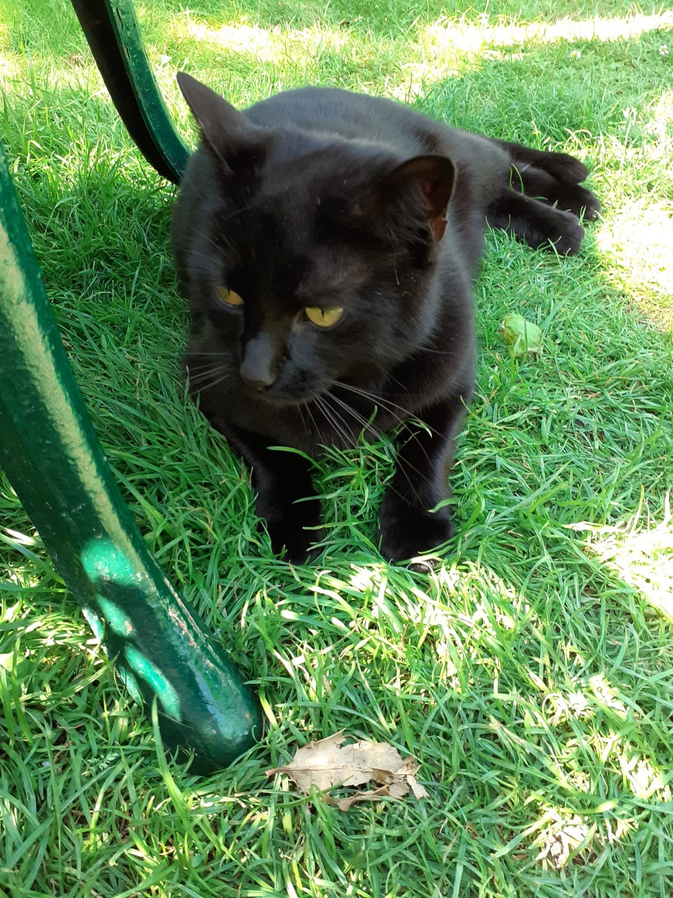

Jasper
I've got three words to describe jasper stupid lazy and funny. He loves playing with the cat toy I made him. All he does is sit around and eat like jack although he pees in the hall. Jasper is 6 and is a bit of a fatty like jack.
Here's the funny animal.
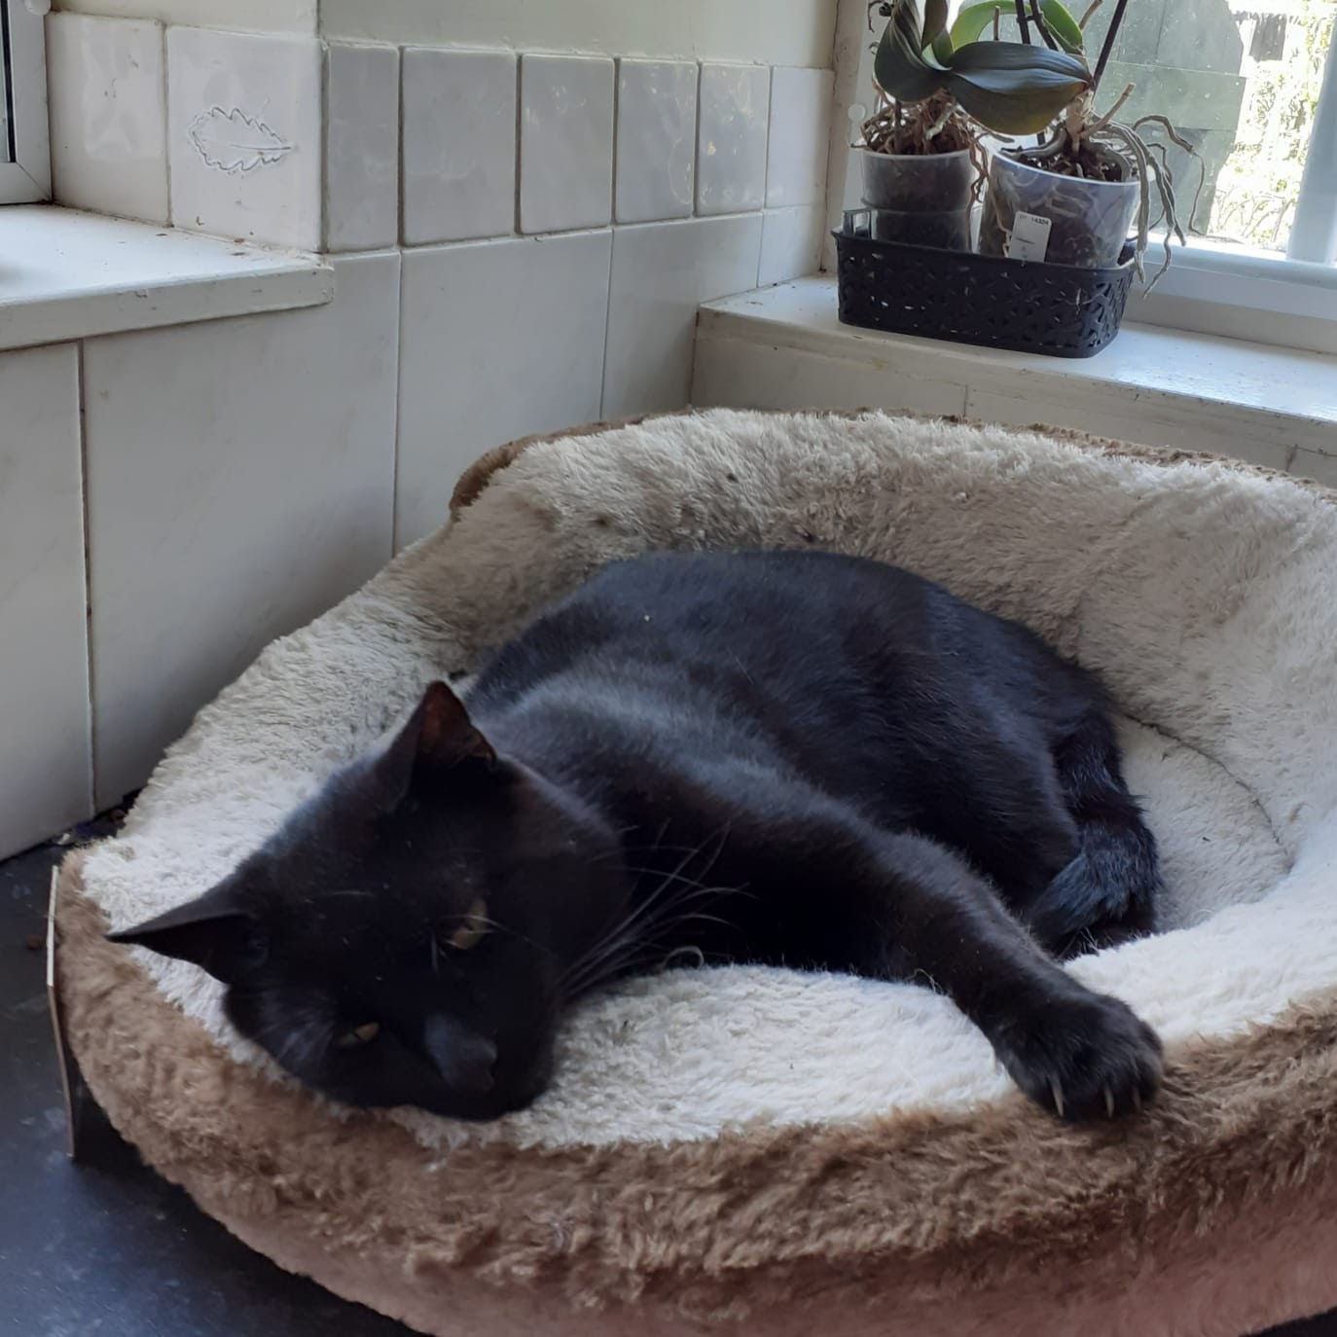

Robbie
Robbie is funny, playful and a bit soft in the head .He's a jealous dog when mum hugs the cat or hugs me or xavy
he gets on mum's lap ,funny doggy. He loves going for a swim and playing ball or stick but what he doesn't like is a shower you gotta smell good robbie. He is nearly four and this year he's having a party!Here's the little party animal in his sunnys.
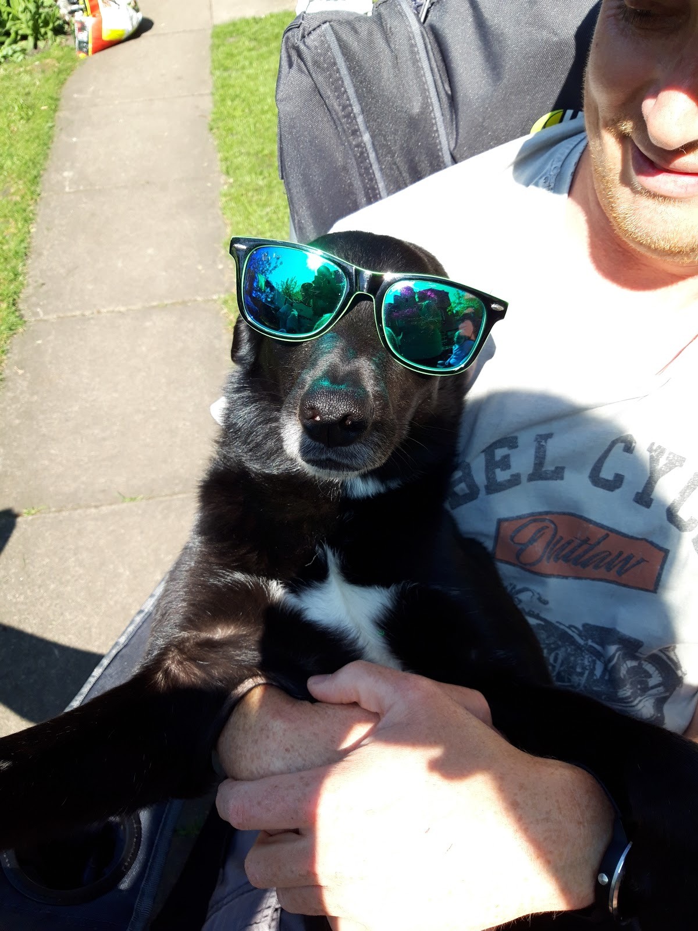

Ginny and luna
The dos amigos
Ginny and Luna are my beloved children. They love going out to play in our small back garden. Their favorite food is grass
or kale. They like lying in the sun and scaring me to death thinking they're dead meanies!!!
Here are my beautiful children.
