How to take care of a gold fish.

- There are many things you need to take care of gold fish such as

- A tank ( Tank Size for fancy goldfish, the general stocking rule of thumb is 10-20 gallons for each fish. Single-tailed fish need far more room, and at least 40 gallons for the first fish and 20 for each additional fish)

- A filter ( A filter should be able to cycle through the volume of water in your fish tank 10 times per hour. So, if you have a 10-gallon goldfish tank, that means the filter needs to be able to cycle 100 gallons of water every hour )

- Air pump ( Adding a pump will keep the water moving so that more oxygen can get into the water from the air )

- Fish food ( In the wild, goldfish eat crustaceans, plants, insects, and smaller fish. Since they eat plants and animals, you need to take their natural diet into account when you decide how to feed them in the aquarium.)

- Water Without chlorine ( You can use chemicals to take the chlorine out which would take you one to two hours or you could wait for the chlorine to go away this would take 24 hours minimum but for the best result wait 5 days)

Now you know the bare necessities you can get decorations ( decor the fish can hide in is great as it make the fish feel more safe )If you want you can add plants to add more oxygen to your tank. (if you want sand or gravel for them to play in or search for food in )

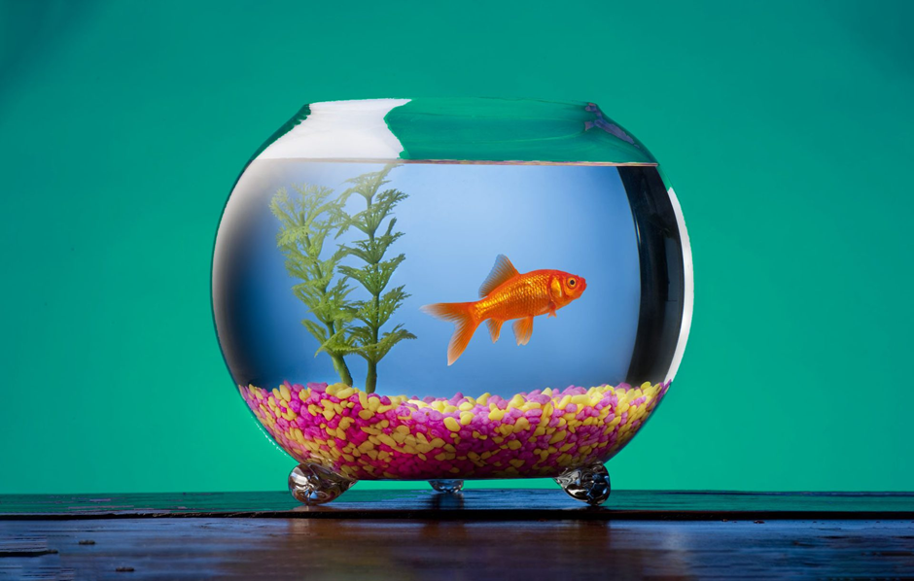

Gold fish diseases
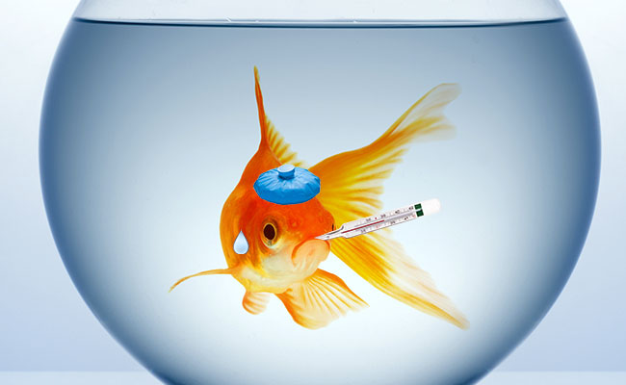

Like humans fish can catch diseases and some diseases can kill the fish! This list will show you types of diseases and what they do :

- Dropsy, Dropsy is a disease where the fish will behave differently and sill start to swell in the stomach and other places symptoms of dropsy are Refusing food, swollen belly, scales that stand out with a pine cone appearance, Pale gills, The anus becomes red and swollen, Feces that are pale and stringy, Ulcers on the body along the lateral line, a spine that is curved, Fins clamed together, Redness in the skin or fins, General lethargy, swimming near the surface or bottom of the tank for a while.

To cure dropsy is quite hard but there is a way! You must spot dropsy in the early stages if the belly has swollen a lot and the scales stand out it will be too late and you cannot cure it, once you spot dropsy you must change the water of the tank and add internal medicine to the tank’s water but there’s not a high chance that it will live sadly.

- White spot, white spot is a parasite that will end up killing the fish if untreated. At first the fish will have white spots on them which make the fish look like its been sprinkled with salt, but then you may notice the fish rubbing itself on objects in the tank in irritation, They may even rapidly move there gills, be lethargic or sit at the bottom of the tank. To treat white spot you will have to treat the whole tank to get rid of this parasite for gold fish you must add aquarium salt and white spot medication.

- Fin/Tail trot, Fin/Tail rot can’t kill the fish but if you see a fish’s fins have holes in them or tails have frayed and the edges appear white they might be rotting. Your fish might also be settled at the bottom of the tank and stop eating this can be caused by poor water quality, but it can be started by bullying from other fish if your fish is being bullied you should move them to a quarantine tank. You can treat this condition by checking the tank’s water condition and doing a 25 per cent change of the water, along with a gravel siphon of the bottom of the tank. You can treat fin and tail rot with Furan 2 and Melafix or with an antibiotic that your Greencross Vets can prescribe.

- Swim bladder disorders, Fish is unable to swim normally because of buoyancy or balance problems.Swim bladder disorders cause fish to float to the surface or sink to the bottom. The most common cause is indigestion/constipation brought on by poor quality food

There are so many diseases to watch out for but theses are the most common ones. At the start Swim bladder disorders and dropsy look very similar so pay close attention.
Goldfish love to...
- play all day and explore your aquarium (large spaces)
- eat tasty and healthy food (varied diet)
- have lots of friends
- take a nap once in a while (when they get tired)
- hide behind a plant or in a cave when they feel in danger
- mating during breeding season (get frisky when water becomes warm)
- eat from owners hand (when they get used to you)

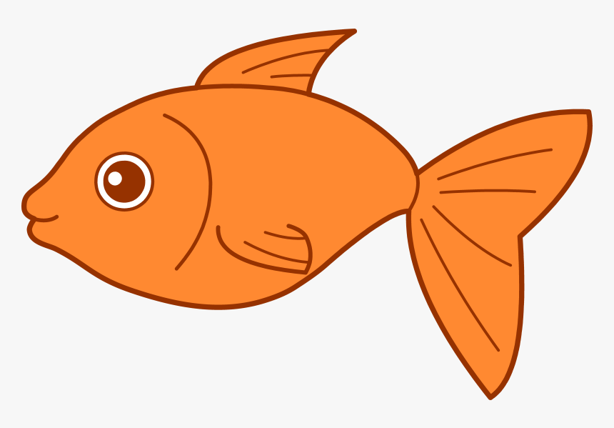

Goldfish don't like to to...
- swim upside-down
- stay all day at the bottom of the aquarium
- live in an unhealthy environment
- live in small places like bowls or small tanks
- contact diseases
- eat only goldfish flakes every day
- have to swim at the top to get more oxygen
- get chased by other fish
- get touched by the owner
- have the lights turned On at night
- listen to loud music
- scratch itself against the sides

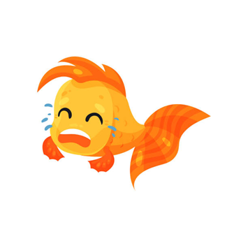
When we got the first two fish
( 10th Oct 2019 )
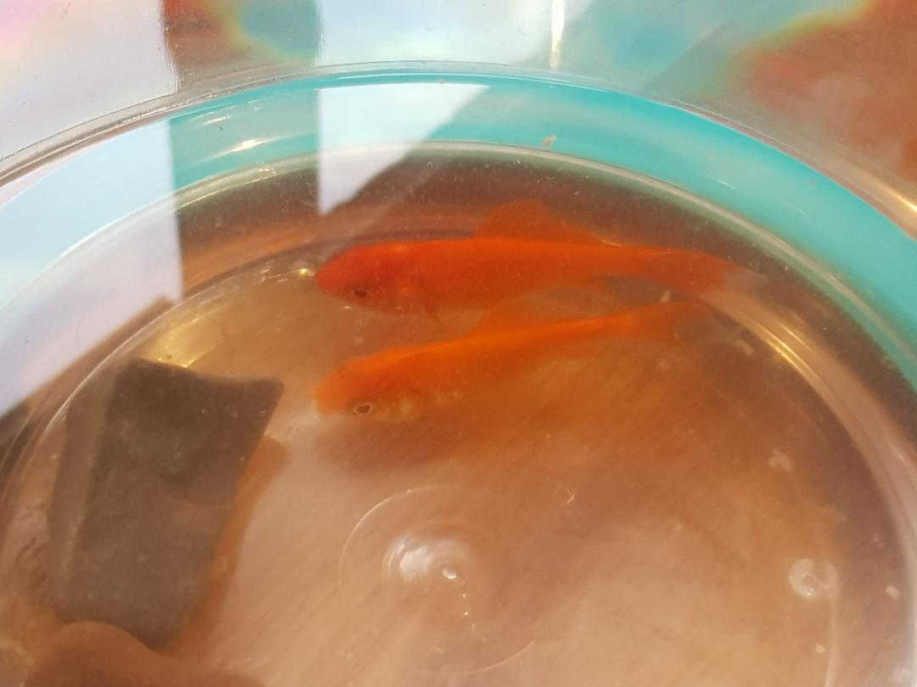

When we got two more fish
(16 nov 2019 )
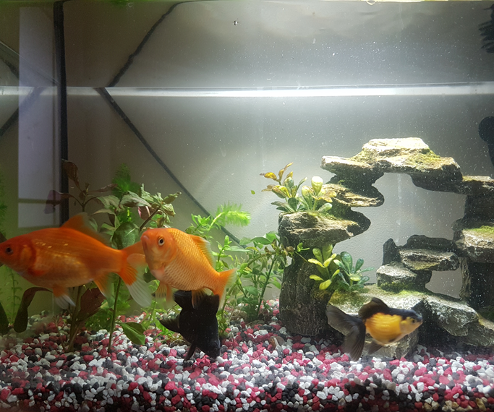

Seven months later ( today )

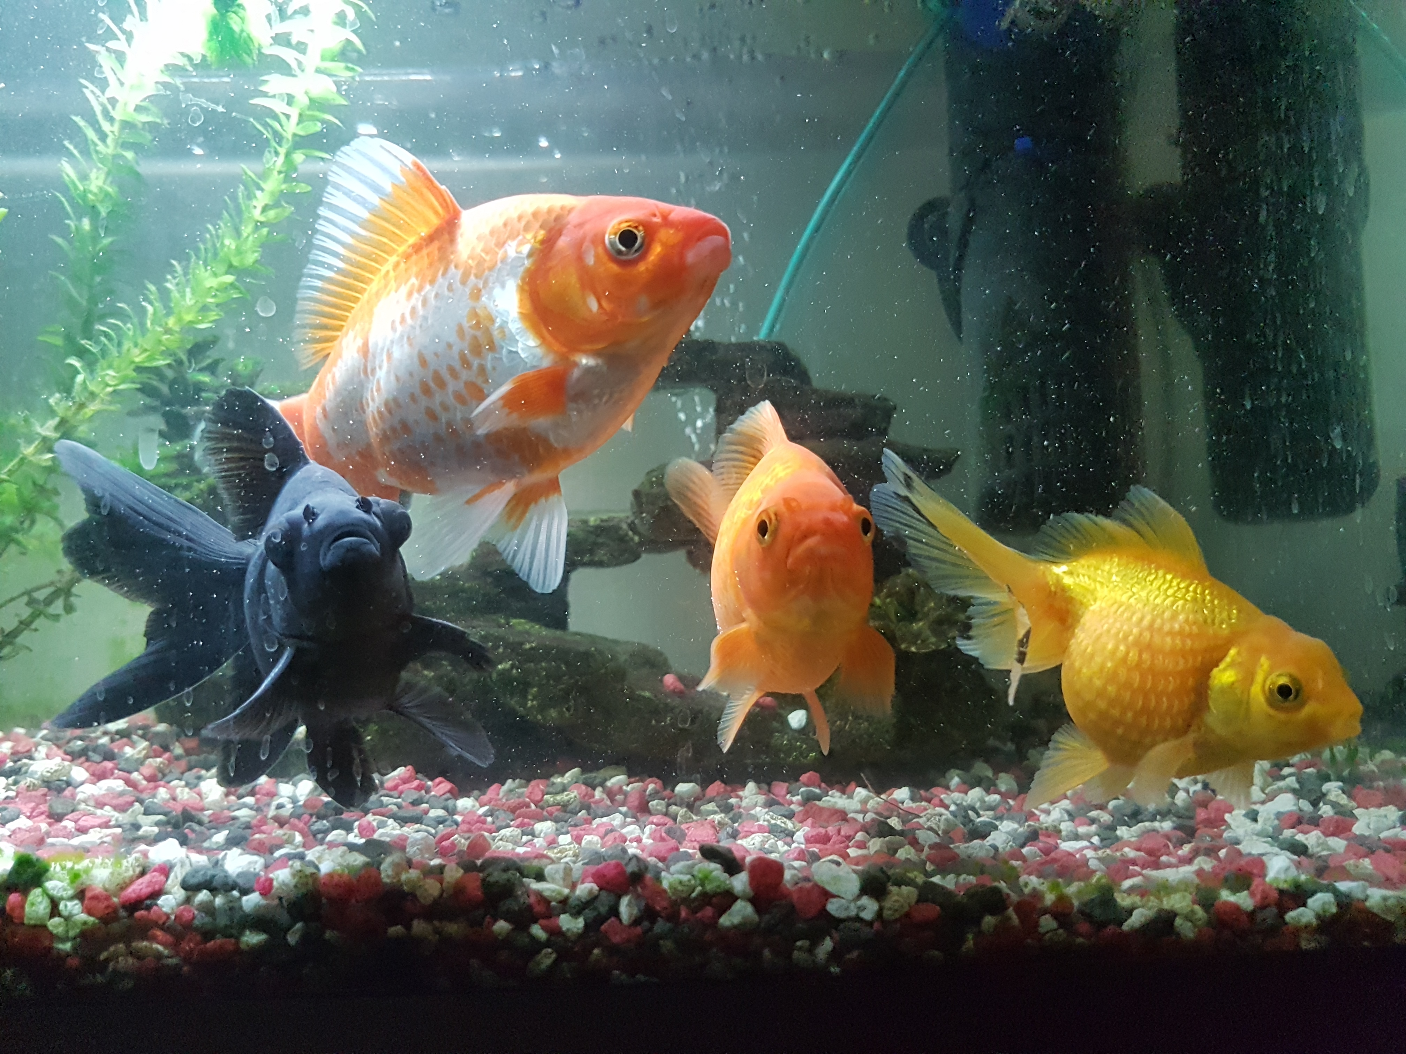

Now our Four Musketeers
These are our pets: the black fish is Moon He’s a Black moor goldfish. The second fish is Ramen He’s a comet Goldfish. The third one is Sushi He’s a common Goldfish. Last but not least is Terry Because when we got him the colours of him reminded us of Terrys chocolate orange, He’s a pearl scale. Did you know in wildlife some goldfish can live up to 25 years? The oldest gold fish in the world is 43 years old!

----------------------------------------

