

# Ashchurch Primary School -

# Monitor your school attendance summary report

Spring term 2024 to 2025

###### 22 April 2025

## Version History

This table gives details of changes made to your summary report for the spring term.

| **Version** | **Changes** | **Date** | **Author** |
| --- | --- | --- | --- |
| 1.0 | Initial release | 22 April 2025 | FT |

## Your attendance summary report

This report is specific to your school. It is a summary of your school’s attendance **for pupils in years 1 to 6** from the start of the academic year 2024 to 2025 up to Tuesday 08 April 2025. Results are based on the [daily attendance data](https://www.gov.uk/guidance/share-your-daily-school-attendance-data) your school shares with the Department for Education (DfE). It comes from your school’s management information system (MIS).

Year-to-date attendance data for the whole school and individual pupils is available using the Monitor your school attendance tool via the [View your education data (VYED)](https://viewyourdata.education.gov.uk/) service.

### How to use this report

Attendance summary reports are designed to help you to meet expectations set out in the [working together to improve school attendance guidance](https://www.gov.uk/government/publications/working-together-to-improve-school-attendance). We publish a new report for your school for each half and full term.

It can help you:

* identify pupils with and approaching persistent and severe absence rates
* consider the underlying causes of absence
* devise strategies to address absence challenges

Share it with your academy trust, governing body, or local authority to discuss current strategies to attendance, their effectiveness and whether alternative approaches are needed.

## How we calculate your results

The data:

* is from the start of the academic year up to Tuesday 08 April 2025.
* is for pupils in years 1 to 6
* includes attendance and absence codes, and pupil characteristics as recorded in your school’s MIS.

Refer to the [data definitions](https://www.gov.uk/government/publications/monitor-your-school-attendance-user-guide/monitor-your-school-attendance-user-guide#data-definitions) to understand how we calculate attendance.

#### National average

The national averages in this report are for pupils in years 1 to 6 in mainstream primary schools in England.

### Comparing your results with other attendance statistics

Comparisons with other data sets should be used with caution. They may be calculated differently or cover different time periods. This can cause large differences in results for each attendance measure.

### Data protection and data sharing

This report can contain sensitive information about your school. It is your responsibility to make sure you store and share the data securely. Review the [data protection impact assessment (DPIA)](https://assets.publishing.service.gov.uk/media/66d83f677a73423428aa2f14/School_attendance_data_collection_DPIA.pdf) for the daily attendance data collection.

## Headline attendance and absence

Overall attendance and persistent absence percentage for your school compared to the national average from the start of the academic year 2024 to 2025, up to Tuesday 08 April 2025.

### Overall school attendance

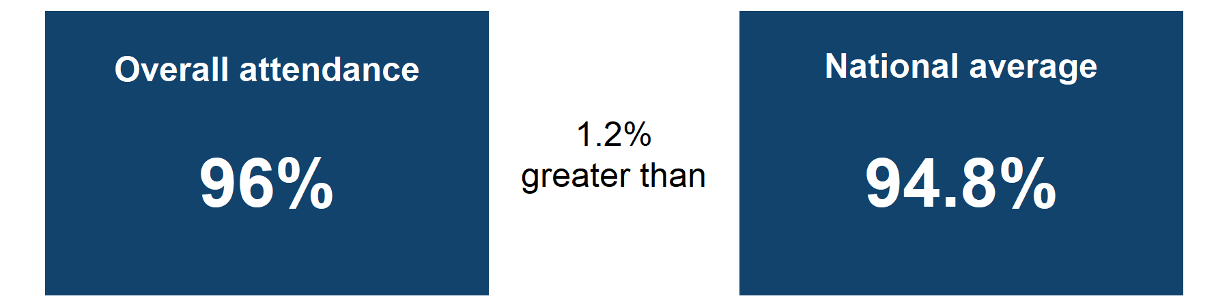

Overall attendance is 96% which is 1.2% greater than the national average.

### Absence breakdown

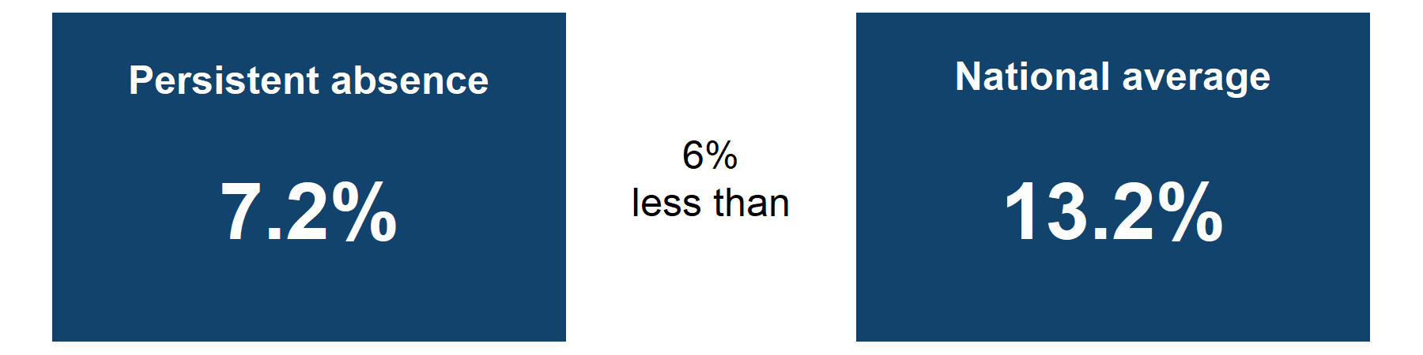

Persistent absence is 7.2% which is 6% less than the national average.

Sources:[Monitor your school attendance results](https://viewyourdata.education.gov.uk/) for your school and nationally, data from the DfE.

Notes:

You can get year-to-date attendance figures for your school via the Monitor your school attendance tool.

## Overall school attendance

### Weekly attendance comparison for the second half of the spring term 2024 to 2025

**Figure 1: Overall attendance percentage for years 1 to 6 in your school compared to the national average. Data is broken down by week, from Monday 24 February 2025 up to Tuesday 08 April 2025.**

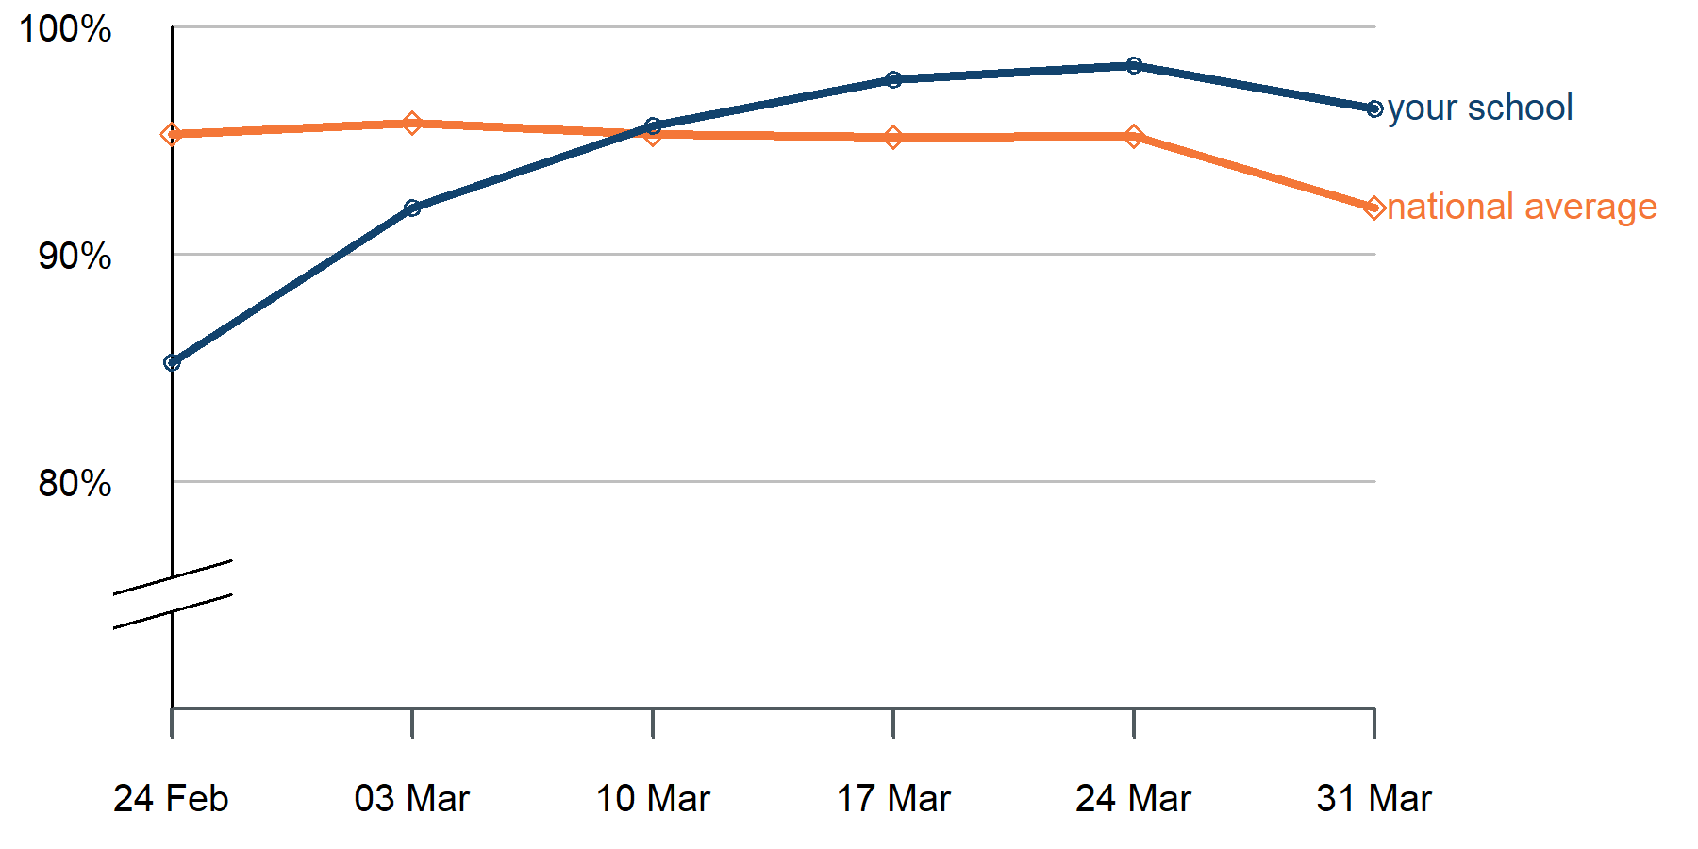

#### Graph alternative: table of weekly attendance for the second half of the spring term 2024 to 2025

| **Week start date** | **Attendance** | **National average** |
| --- | --- | --- |
| **24/02/2025** | 85.2% | 95.3% |
| **03/03/2025** | 92% | 95.8% |
| **10/03/2025** | 95.7% | 95.3% |
| **17/03/2025** | 97.7% | 95.2% |
| **24/03/2025** | 98.3% | 95.2% |
| **31/03/2025** | 96.4% | 92% |

Sources: [Monitor your school attendance results](https://viewyourdata.education.gov.uk/) for your school and nationally, data from the DfE.

Notes:

Attendance results for your school and individual pupils are updated daily via the Monitor your school attendance tool.

[Pupil attendance in schools](https://explore-education-statistics.service.gov.uk/find-statistics/pupil-attendance-in-schools) data from national and local authorities is published on Explore Education Statistics every 2 weeks.

### Attendance by pupil group

**Figure 2: Bar chart showing attendance percentages for different pupil groups compared to the national averages. Results are based on pupils with free school meals (FSM) and special educational needs (SEN) support in years 1 to 6 from the start of the academic year 2024 to 2025, up to Tuesday 08 April 2025**.

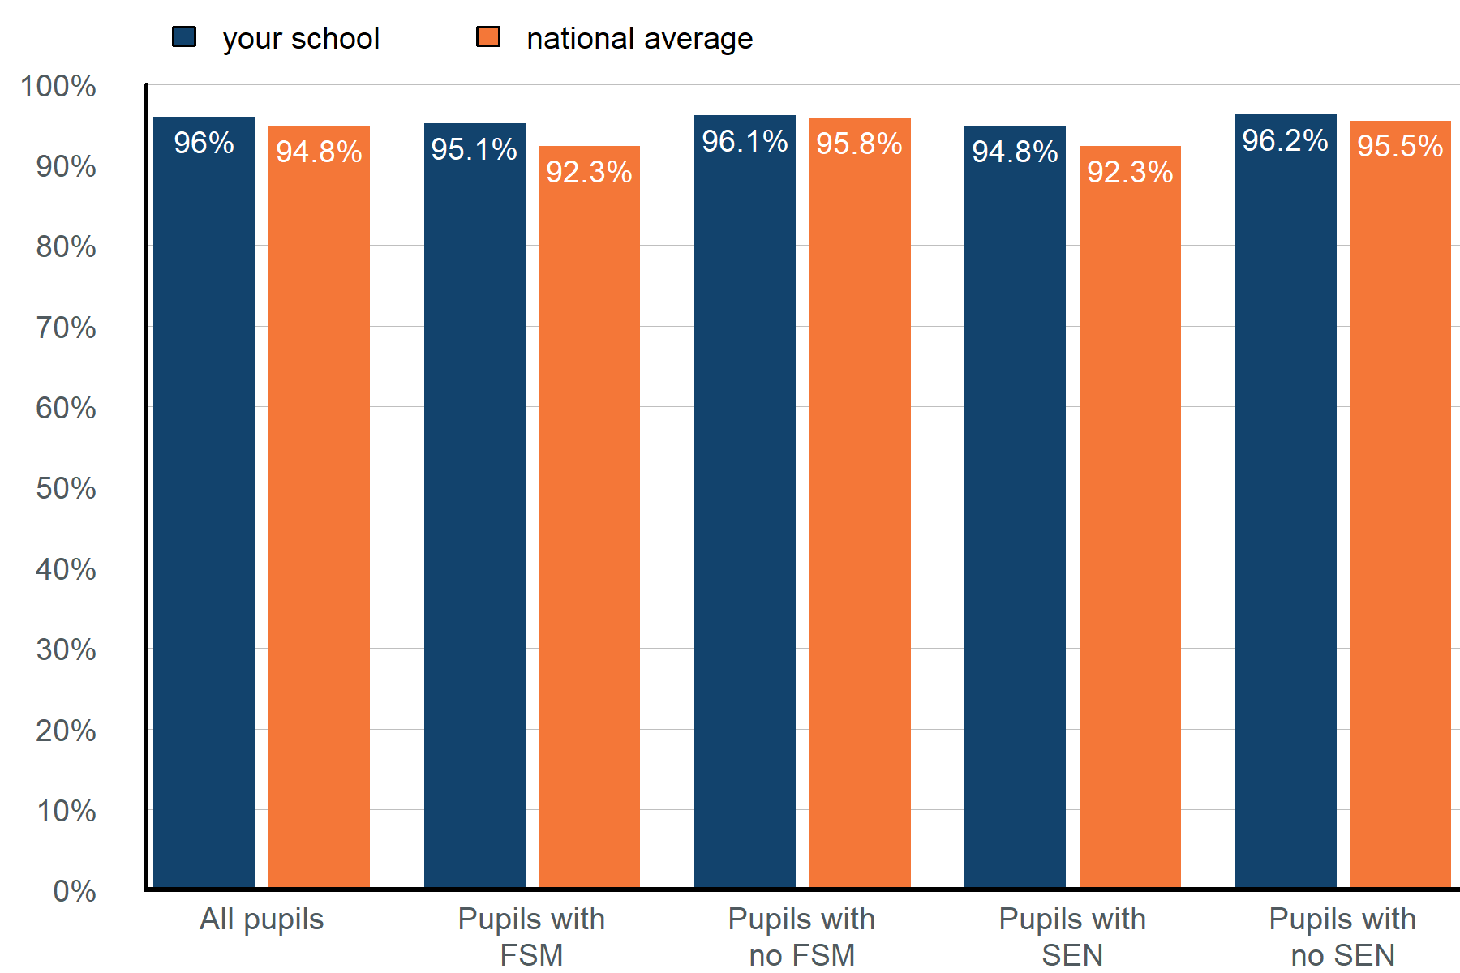

#### Graph alternative: table of attendance by pupil groups from the start of the academic year 2024 to 2025, up to Tuesday 08 April 2025.

| **Pupil group** | **Attendance** | **National average** |
| --- | --- | --- |
| **All pupils** | 96% | 94.8% |
| **Pupils with FSM** | 95.1% | 92.3% |
| **Pupils with no FSM** | 96.1% | 95.8% |
| **Pupils with SEN** | 94.8% | 92.3% |
| **Pupils with no SEN** | 96.2% | 95.5% |

Sources: [Monitor your school attendance results](https://viewyourdata.education.gov.uk/) for your school and nationally, data from the DfE.

Notes:

Special education needs (SEN) support data is taken from the latest record available in your management information system (MIS). SEN support pupil numbers include those with an education health and care plan (EHCP).

Year-to-date attendance figures for SEN and EHCP pupils are available via the Monitor your school attendance tool.

### Previous academic year comparison

**Figure 3: Bar chart showing attendance for your school and different pupil groups from the start of the academic year 2024 to 2025, up to Tuesday 08 April 2025 compared to the same time period in the previous academic year**.

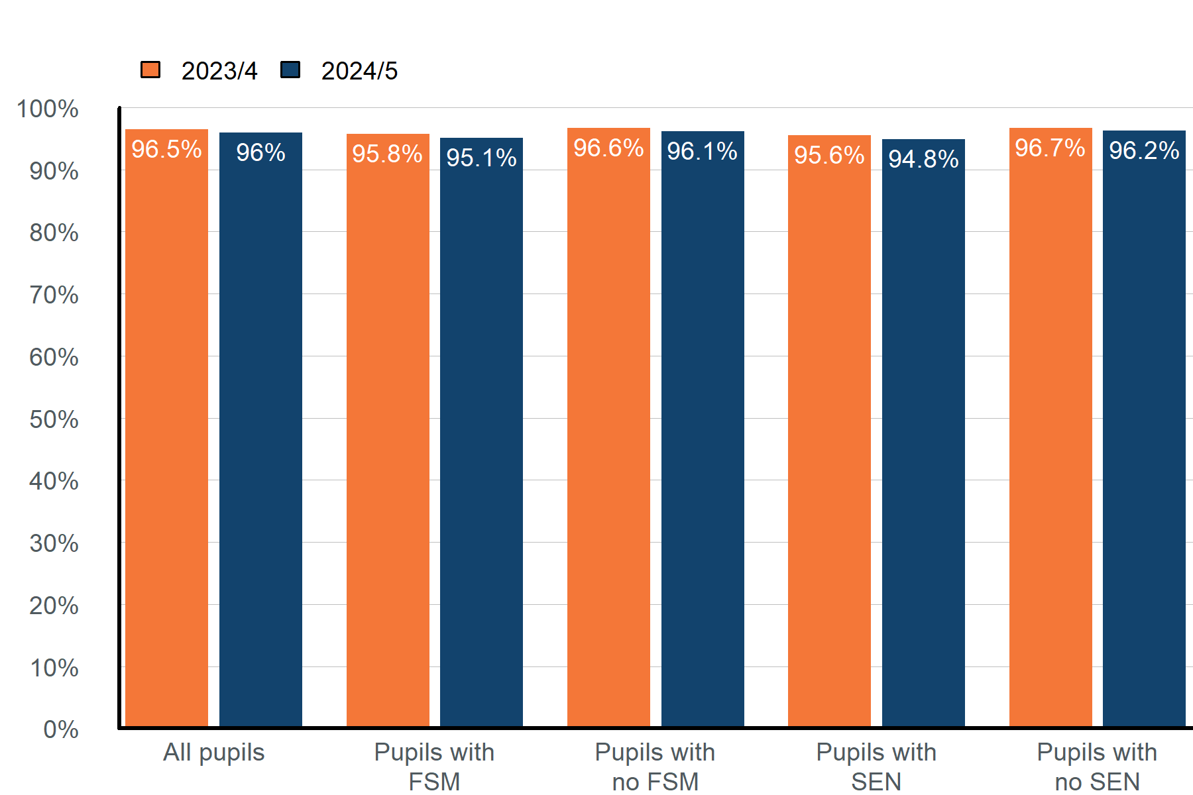

#### Graph alternative: table of attendance by pupil groups from the start of the academic year 2024 to 2025, up to Tuesday 08 April 2025 , compared to the same period in the previous academic year.

| **Pupil group** | **Attendance 2023/4** | **Attendance 2024/5** |
| --- | --- | --- |
| **All pupils** | 96.5% | 96% |
| **Pupils with FSM** | 95.8% | 95.1% |
| **Pupils with no FSM** | 96.6% | 96.1% |
| **Pupils with SEN** | 95.6% | 94.8% |
| **Pupils with no SEN** | 96.7% | 96.2% |

Sources: [Monitor your school attendance results](https://viewyourdata.education.gov.uk/) for your school, data from the DfE.

Notes:

You can compare the current and previous academic year for the whole school, an individual pupil or pupil characteristic groups via the Monitor your school attendance tool:

* Year-to-date report
* Previous academic year report

## Absence by year group

**Figure 4: Table showing the percentage of pupils in each year group in each 5% absence band up to 50% and above, from the start of the academic year 2024 to 2025, up to Tuesday 08 April 2025. Results are based on pupils with 20 or more possible sessions in the academic year-to-date**.

| **Overall Absence Band** | **Year 1** | **Year 2** | **Year 3** | **Year 4** | **Year 5** | **Year 6** |
| --- | --- | --- | --- | --- | --- | --- |
| **less than 5%** | 59% | 80% | 75% | 76% | 86% | 60% |
| **5% to less than 10%** | 29% | 15% | 20% | 20% | 9% | 25% |
| **10% to less than 15%** | 6% | 0% | 5% | 4% | 5% | 10% |
| **15% to less than 20%** | 6% | 0% | 0% | 0% | 0% | 5% |
| **20% to less than 25%** | 0% | 0% | 0% | 0% | 0% | 0% |
| **25% to less than 30%** | 0% | 0% | 0% | 0% | 0% | 0% |
| **30% to less than 35%** | 0% | 5% | 0% | 0% | 0% | 0% |
| **35% to less than 40%** | 0% | 0% | 0% | 0% | 0% | 0% |
| **40% to less than 45%** | 0% | 0% | 0% | 0% | 0% | 0% |
| **45% to less than 50%** | 0% | 0% | 0% | 0% | 0% | 0% |
| **50% and above (severely absent)** | 0% | 0% | 0% | 0% | 0% | 0% |
| **10% and above (persistently absent)** | 12% | 5% | 5% | 4% | 5% | 15% |

Sources: [Monitor your school attendance results](https://viewyourdata.education.gov.uk/) for your school, data from the DfE.

Notes:

Absence data is updated daily via the Monitor your school attendance tool. Use the absence bandings report to review the absence distribution for each of your schools, following the approach set out in the [absence bandings user guide](https://www.gov.uk/government/publications/monitor-your-school-attendance-user-guide/monitor-your-school-attendance-how-to-use-the-absence-bandings-report) on GOV.UK.

© Crown copyright 2025