

# Ashchurch Primary School -

# Attendance summary report

Monitor your school attendance

###### First half of the Summer term 2024 to 2025

## Version History

This table gives details of changes made to your summary report for the summer term.

| Version | Changes | Date | Author |
| --- | --- | --- | --- |
| 1.0 | Initial release | 10 June 2025 | FT |

## Your attendance summary report

This report is specific to your school. It is a summary of your attendance for pupils in years 1 to 6 compared to the national average. You get a new report at the end of each half and full term.

Use it to compare:

* overall attendance
* persistent absence
* attendance for different groups of pupils, including those with special education needs (SEN) support and free school meals (FSM)
* attendance in the current academic year with last year

Refer to the [data definitions](https://www.gov.uk/government/publications/monitor-your-school-attendance-user-guide/monitor-your-school-attendance-user-guide#data-definitions) to understand how we calculate attendance.

The data:

* is for pupils in years 1 to 6
* is from the start of the academic year up to Friday 30 May 2025.
* is based on the [daily attendance data](https://www.gov.uk/guidance/share-your-daily-school-attendance-data) schools share with the Department for Education (DfE)
* includes attendance and absence codes, and pupil characteristics as recorded in your school’s MIS.

Year-to-date attendance data for the whole school and individual pupils is available using the Monitor your school attendance tool via the [View your education data (VYED)](https://viewyourdata.education.gov.uk/) service.

### How to use this report

Share it with your academy trust, governing body, or local authority to discuss current strategies for attendance, their effectiveness and whether alternative approaches are needed.

Use caution when comparing the results in this report with other statistics. They may be calculated differently or cover different time periods, causing large differences in results.

You should maintain high aspirations for all pupils and put strategies in place to review any gaps in attendance for specific groups in line with schools’ responsibilities in chapter 2 of the [Working together to improve school attendance](https://www.gov.uk/government/publications/working-together-to-improve-school-attendance) guidance.

### National average

The national averages in this report are for pupils in years 1 to 6 in mainstream primary schools in England.

### Data protection and data sharing

This report can contain sensitive information about your school. It is your responsibility to make sure you store and share the data securely. Review the [data protection impact assessment (DPIA)](https://assets.publishing.service.gov.uk/media/66d83f677a73423428aa2f14/School_attendance_data_collection_DPIA.pdf) (PDF, 241 KB, 21 pages) for the daily attendance data collection.

## Headline attendance and absence

Overall attendance and persistent absence figures for pupils in years 1 to 6 compared to the national average. Results are calculated based on data from the start of the academic year 2024 to 2025, up to Friday 30 May 2025.

### Overall attendance

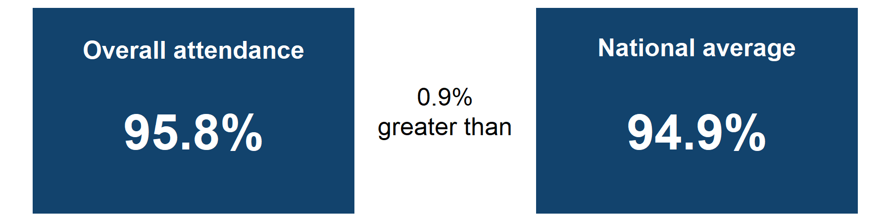

Overall attendance is 95.8% which is 0.9% greater than the national average.

### Persistent Absence

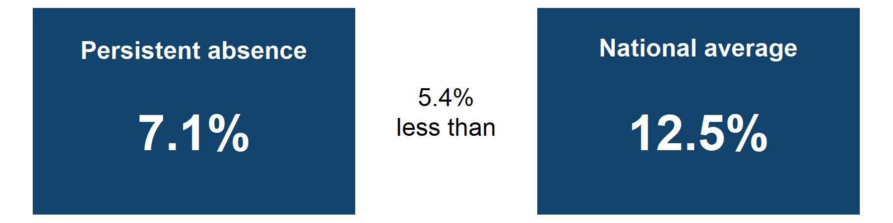

Persistent absence is 7.1% which is 5.4% less than the national average.

Sources:[Monitor your school attendance results](https://viewyourdata.education.gov.uk/) for your school and nationally, data from the DfE.

Notes:

You can get year-to-date attendance figures for your school via the Monitor your school attendance tool.

## Overall attendance comparison

### Weekly attendance comparison for the first half of the summer term 2024 to 2025

**Figure 1: Graph showing the overall attendance percentage each week during the first half of the summer term, compared to the national average. Results are for pupils in years 1 to 6 from Monday 21 April 2025 to Friday 30 May 2025.**

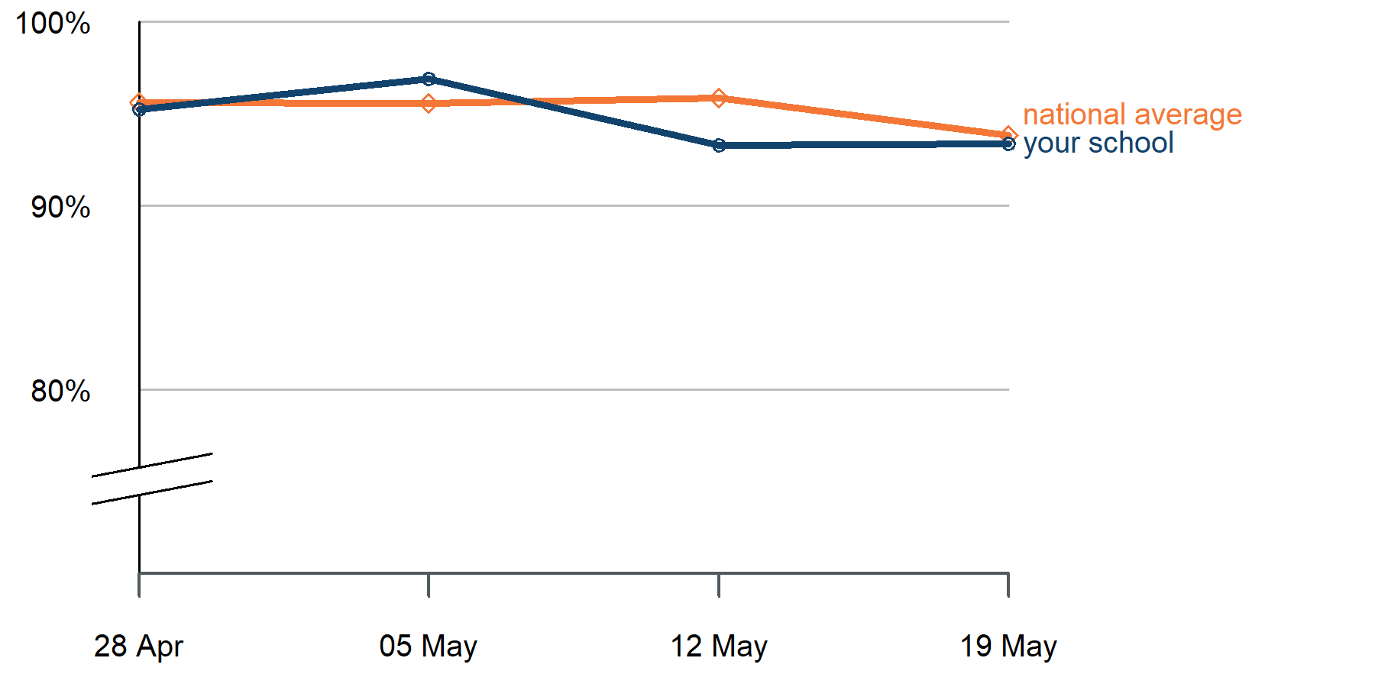

#### Graph alternative: table of weekly attendance for the first half of the summer term 2024 to 2025.

| Week start date | Attendance | National average |
| --- | --- | --- |
| **28/04/2025** | 95.2% | 95.6% |
| **05/05/2025** | 96.9% | 95.6% |
| **12/05/2025** | 93.3% | 95.9% |
| **19/05/2025** | 93.4% | 93.8% |

Sources: [Monitor your school attendance results](https://viewyourdata.education.gov.uk/) for your school and nationally, data from the DfE.

Notes:

Attendance results for your school and individual pupils are updated daily via the Monitor your school attendance tool.

[Pupil attendance in schools](https://explore-education-statistics.service.gov.uk/find-statistics/pupil-attendance-in-schools) data from national and local authorities is published on Explore Education Statistics every 2 weeks.

### Pupil group comparison

**Figure 2: Bar chart showing the attendance percentage for pupils with and without free school meals (FSM) and special educational needs (SEN) compared to the national averages. Results are for pupils in years 1 to 6 from the start of the academic year 2024 to 2025, up to Friday 30 May 2025**.

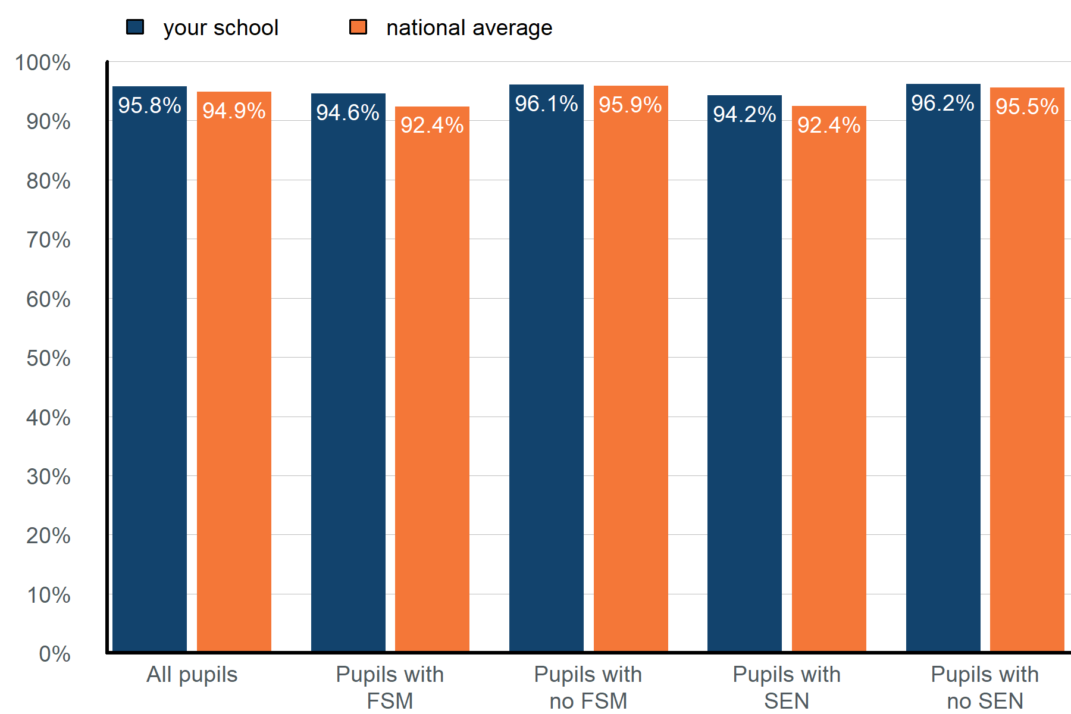

#### Graph alternative: table of attendance for different pupil groups from the start of the academic year 2024 to 2025, up to Friday 30 May 2025.

| Pupil group | Attendance | National average |
| --- | --- | --- |
| **All pupils** | 95.8% | 94.9% |
| **Pupils with free school meals (FSM)** | 94.6% | 92.4% |
| **Pupils with no FSM** | 96.1% | 95.9% |
| **Pupils with special educational needs (SEN) support** | 94.2% | 92.4% |
| **Pupils with no SEN** | 96.2% | 95.5% |

Sources: [Monitor your school attendance results](https://viewyourdata.education.gov.uk/) for your school and nationally, data from the DfE.

Notes:

Special education needs (SEN) support data is taken from the latest record available in your management information system (MIS). SEN support pupil numbers include those with an education health and care plan (EHCP).

Year-to-date attendance figures for SEN and EHCP pupils are available via the View your school attendance data dashboard.

## Attendance insights for your school

### Previous academic year comparison

**Figure 3: Bar chart showing the attendance percentage for pupils with and without free school meals (FSM) and special educational needs (SEN) compared to last year. Results are for pupils in years 1 to 6 from the start of the academic year 2024 to 2025, up to Friday 30 May 2025**.

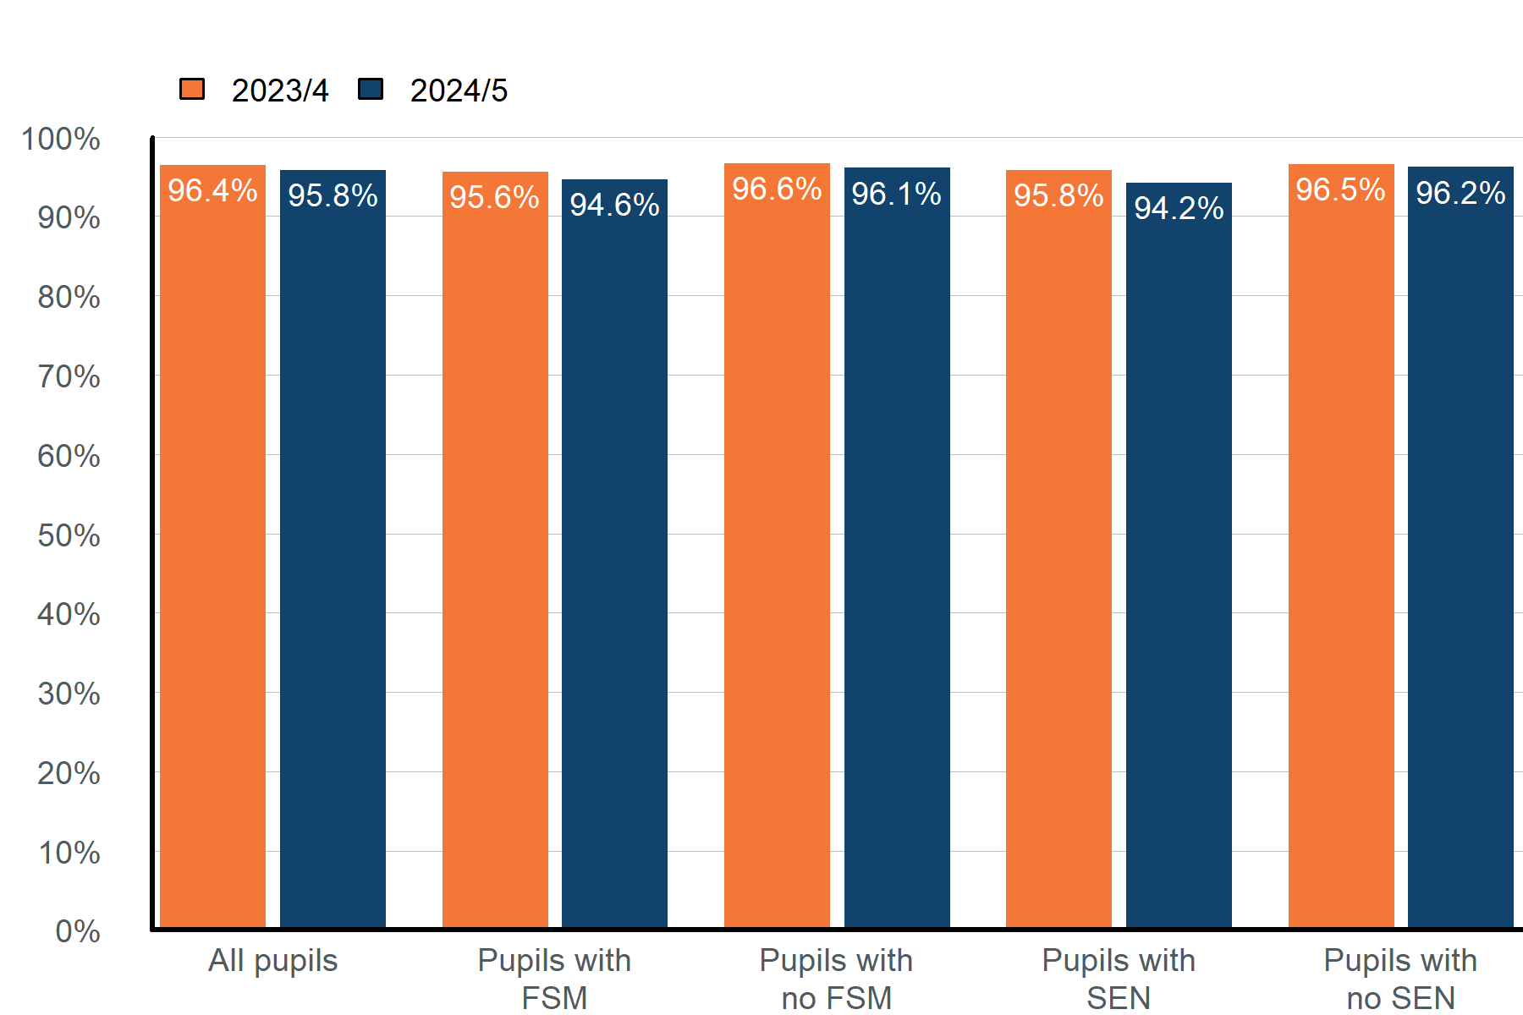

#### Graph alternative: table of attendance for different pupil groups from the start of the academic year 2024 to 2025, up to Friday 30 May 2025 , compared to the same period last year.

| Pupil group | Attendance 2023/4 | Attendance 2024/5 |
| --- | --- | --- |
| **All pupils** | 96.4% | 95.8% |
| **Pupils with free school meals (FSM)** | 95.6% | 94.6% |
| **Pupils with no FSM** | 96.6% | 96.1% |
| **Pupils with special educational needs (SEN) support** | 95.8% | 94.2% |
| **Pupils with no SEN** | 96.5% | 96.2% |

Sources: [Monitor your school attendance results](https://viewyourdata.education.gov.uk/) for your school, data from the DfE.

Notes:

You can compare the current and previous academic year for the whole school, an individual pupil or pupil characteristic groups via the Monitor your school attendance tool:

* Year-to-date report
* Previous academic year report

## Absence by year group

**Figure 4: Table showing the percentage of pupils in each 5% absence band up to and above 50% absence for pupils in years Friday 30 May 2025. Results are based on pupils with 20 or more possible sessions in the current academic year, from the start of the academic year up to Friday 30 May 2025**.

| **Overall Absence Band** | **Year 1** | **Year 2** | **Year 3** | **Year 4** | **Year 5** | **Year 6** |
| --- | --- | --- | --- | --- | --- | --- |
| **less than 5%** | 58% | 76% | 75% | 76% | 77% | 70% |
| **5% to less than 10%** | 26% | 14% | 20% | 20% | 23% | 20% |
| **10% to less than 15%** | 5% | 5% | 5% | 4% | 0% | 5% |
| **15% to less than 20%** | 5% | 0% | 0% | 0% | 0% | 5% |
| **20% to less than 25%** | 0% | 0% | 0% | 0% | 0% | 0% |
| **25% to less than 30%** | 5% | 0% | 0% | 0% | 0% | 0% |
| **30% to less than 35%** | 0% | 5% | 0% | 0% | 0% | 0% |
| **35% to less than 40%** | 0% | 0% | 0% | 0% | 0% | 0% |
| **40% to less than 45%** | 0% | 0% | 0% | 0% | 0% | 0% |
| **45% to less than 50%** | 0% | 0% | 0% | 0% | 0% | 0% |
| **50% and above (severely absent)** | 0% | 0% | 0% | 0% | 0% | 0% |
| **10% and above (persistently absent)** | 16% | 10% | 5% | 4% | 0% | 10% |

Sources: [Monitor your school attendance results](https://viewyourdata.education.gov.uk/) for your school, data from the DfE.

Notes:

Absence data is updated daily via the Monitor your school attendance tool. Use the absence bandings report to review the absence distribution for each of your schools, following the approach set out in the [absence bandings user guide](https://www.gov.uk/government/publications/monitor-your-school-attendance-user-guide/monitor-your-school-attendance-how-to-use-the-absence-bandings-report) on GOV.UK.

© Crown copyright 2025